Pedigree of:  AM Ch  Arubmec's Sweet Spot  SC (CRd)  M  HM927824/01 (USA)  3 Dec 2000 | AM Ch  Nyanga Signet Sweet William  JC (CRd)  HM823885/01 (USA)  25 Nov 1998  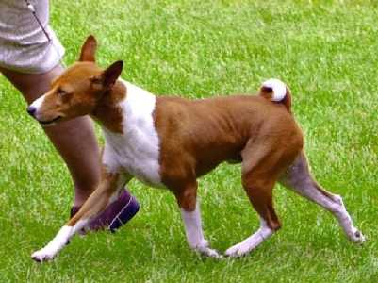 | AM Ch  Reveille Boutonniere  JC (pCL)  HM516728/04 (USA)  12 May 1994 | AM Ch  Juju's Pistol Pete  HD481008 (USA) | AM Ch  Blucrest All Star
AM Ch
Aleika's Destiny
 |  |  | AM Ch  Serengeti Reveille Larkspur  (pCL)  HD698571 (USA) | AM Ch  Termay Dial Reveille
AM Ch
Serengeti Hollyhock
 |  | AM Ch  Kibushi Highfalutin Of Vasia  HM338856/01 (USA)  18 Jan 1991 | Kibushi Spellbinder-Niger  HD907583 (USA) | AM Ch  Silvercreek's Kino
 |  |  |  | Avongara Zamee
 |  |  | AM Ch  Kibushi In The Mood  HD702136 (USA) | AM Ch  Falisha's Night Odysey
AM Ch
Kibushi Quinella Of Bravos
 | AM Ch  Arubmec's Autumn Mist  (pCR)  HM649148/01 (USA)  5 Jul 1996 | AM Ch  Arubmec's Jon-Luke  HM329239/02 (USA)  27 Dec 1990 | AM Ch  Arubmec's The Victor  HD099439 (USA) | CAN/AM Ch  Asari's Envoy
AM Ch
Pero's Cayenne of N'Gi
 |  |  | AM Ch  Arubmec's Liberty Lady  HD670146 (USA) | AM Ch  Djakomba's Spotlight
AM Ch
Arubmec's Thika
 |  | AM Ch  Arubmec's Autumn Serenade  HM489703/03 (USA)  3 Nov 1993 | AM Ch  Jato James T  HM434545/01 (USA) | AM Ch  Arubmec's The Victor
AM Ch
Jato J'Mira
 |  |  | AM Ch  Arubmec's Intruder  HM330525/01 (USA) | AM Ch  Djakomba's Spotlight
AM Ch
Arubmec's Precious Thisbe

