Pedigree of:  AM Ch  Arubmec's Precious Thisbe  F  HD572533 (USA)  28 Nov 1986 | AM Ch  Arubmec's The Victor  HD099439 (USA)  25 Sep 1983  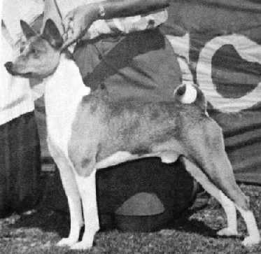 | CAN/AM Ch  Asari's Envoy  HC856283 (USA)  27 Jul 1981 | AM Ch  Absinthe's Red Rocket Bellair  HC456964 (USA) | AM Ch  Reveille Re-Up
AM Ch
Absinthe's Baji Nandi
 |  |  | Asari's Neferteri  HC627248 (USA) | AM Ch  Asari's Ti-Jii
 |  |  |  | Kapki's Juba of Asari
 |  | AM Ch  Pero's Cayenne of N'Gi  HC597505 (USA)  19 Dec 1978 | AM Ch  Pero's Krugerrand  HC389401 (USA) | AM/CAN Ch  Enzi Kidogo of Sun Diata
AM Ch
Pero Precious Charm
 |  |  | AM Ch  Pero's Classy Chassis  HC271057 (USA) | AM Ch  Pero Regal Image
AM Ch
B'Tasi Sirdell
 | AM Ch  Arubmec's Mandy  HD079552 (USA)  25 Sep 1983 | CAN/AM Ch  Asari's Envoy  HC856283 (USA)  27 Jul 1981 | AM Ch  Absinthe's Red Rocket Bellair  HC456964 (USA) | AM Ch  Reveille Re-Up
AM Ch
Absinthe's Baji Nandi
 |  |  | Asari's Neferteri  HC627248 (USA) | AM Ch  Asari's Ti-Jii
 |  |  |  | Kapki's Juba of Asari
 |  | AM Ch  Pero's Cayenne of N'Gi  HC597505 (USA)  19 Dec 1978 | AM Ch  Pero's Krugerrand  HC389401 (USA) | AM/CAN Ch  Enzi Kidogo of Sun Diata
AM Ch
Pero Precious Charm
 |  |  | AM Ch  Pero's Classy Chassis  HC271057 (USA) | AM Ch  Pero Regal Image
AM Ch
B'Tasi Sirdell

